**COMP90007 Internet Technologies**

**Project 1 – Network Analysis**

**Handan Yu**

**HANDANY**

**1235484**

**Section 2**

**Ans 2.1**

**Meaning of parameters:**

* n: Prints hop addresses numerically rather than symbolically and numerically. This flag saves a name-server address-to-name lookup for each gateway found on the path.
* w: Sets the time(in seconds) to wait for a response to a probe
* 1: the time to wait for a response to a probe is 1 seconds

Importance of parameters:

* n: Using IP can increase the speed of implementation, since it can reduce the time of host name resolution.
* w 1: Save test time

**Ans 2.2**

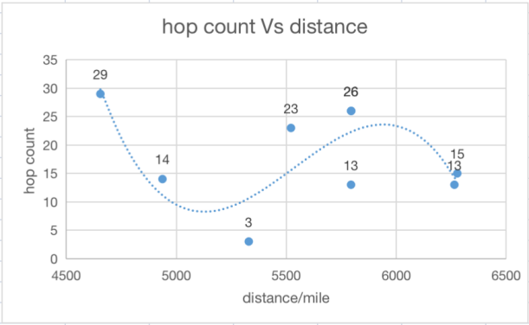

Fig. 2.2

According to Fig. 2.2, there is no an obvious correlation between hop count and distance, though from this figure, when distance between 5000~5500 miles, the hop counts are relatively less. The main reason of such scenario is that there are several kinds of routing algorithm and each of them has different effects on network and router resources, and therefore sometimes the best route will change according to different situations like collisions. Additionally,

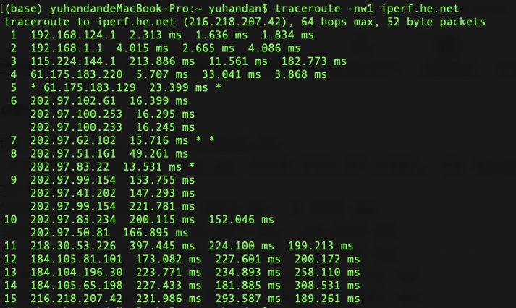

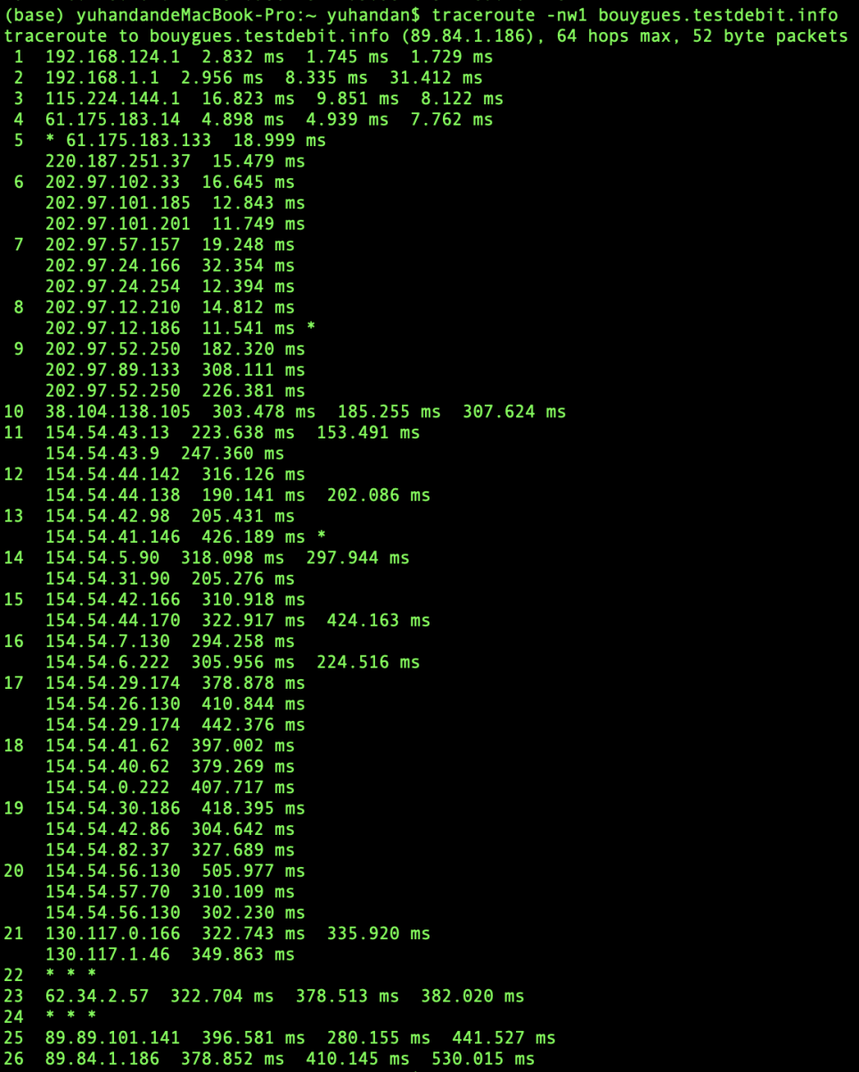

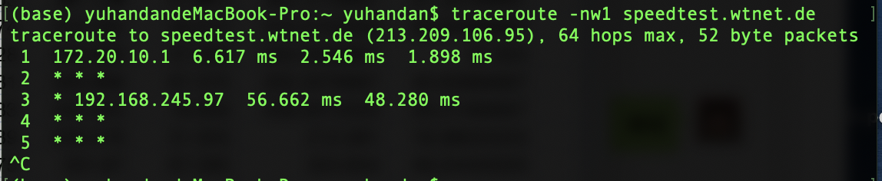

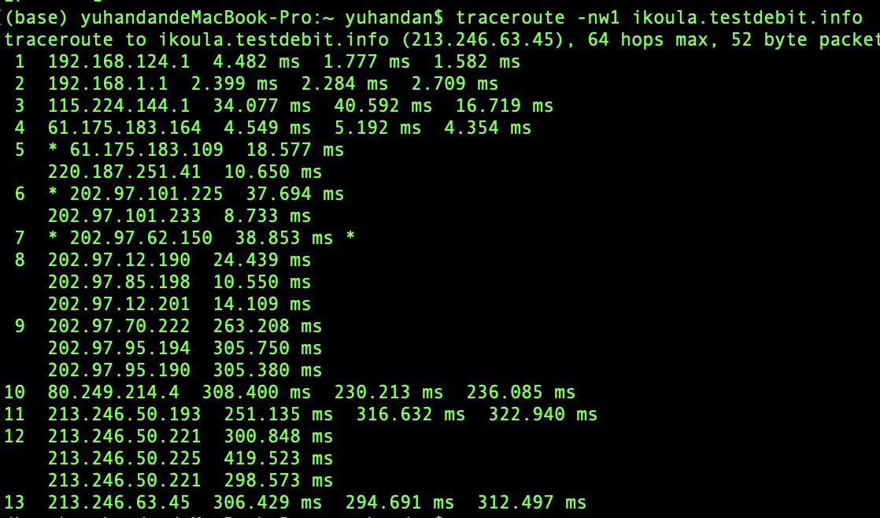

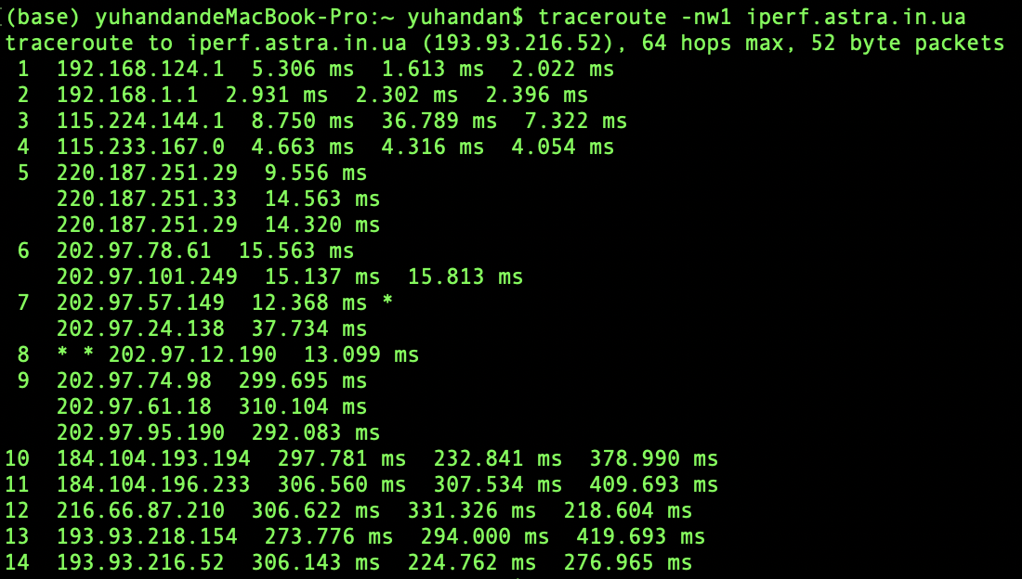

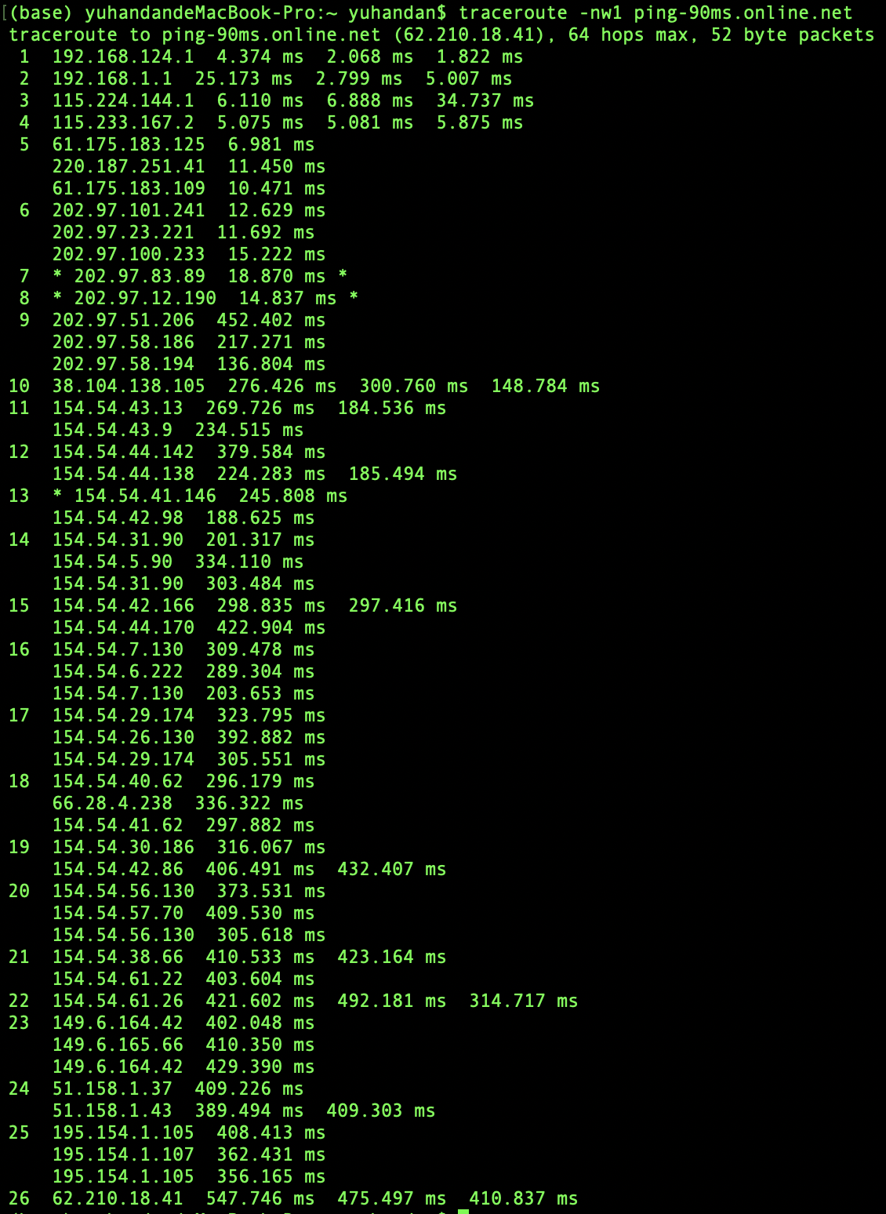

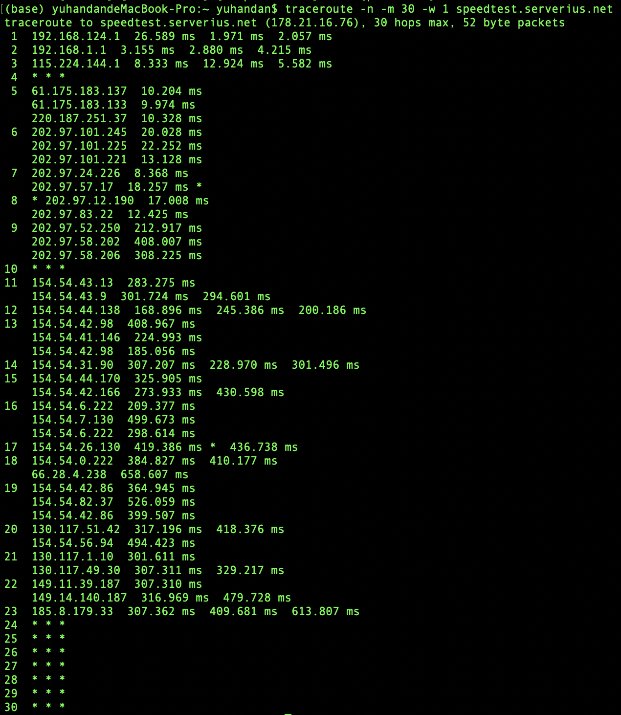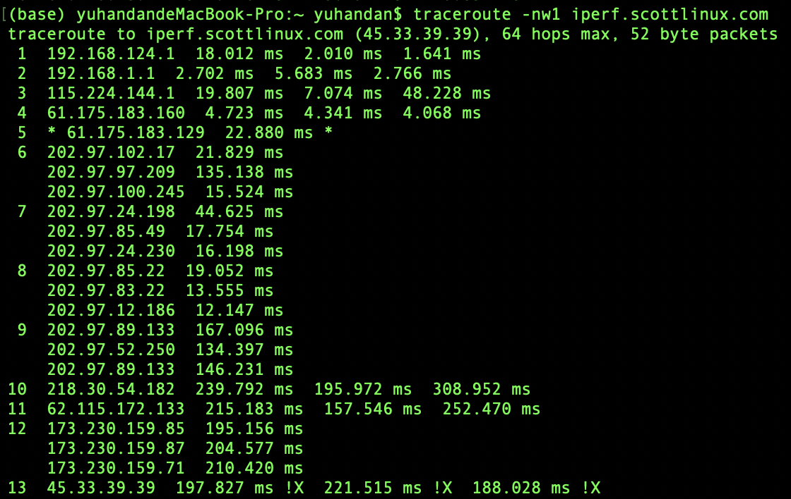

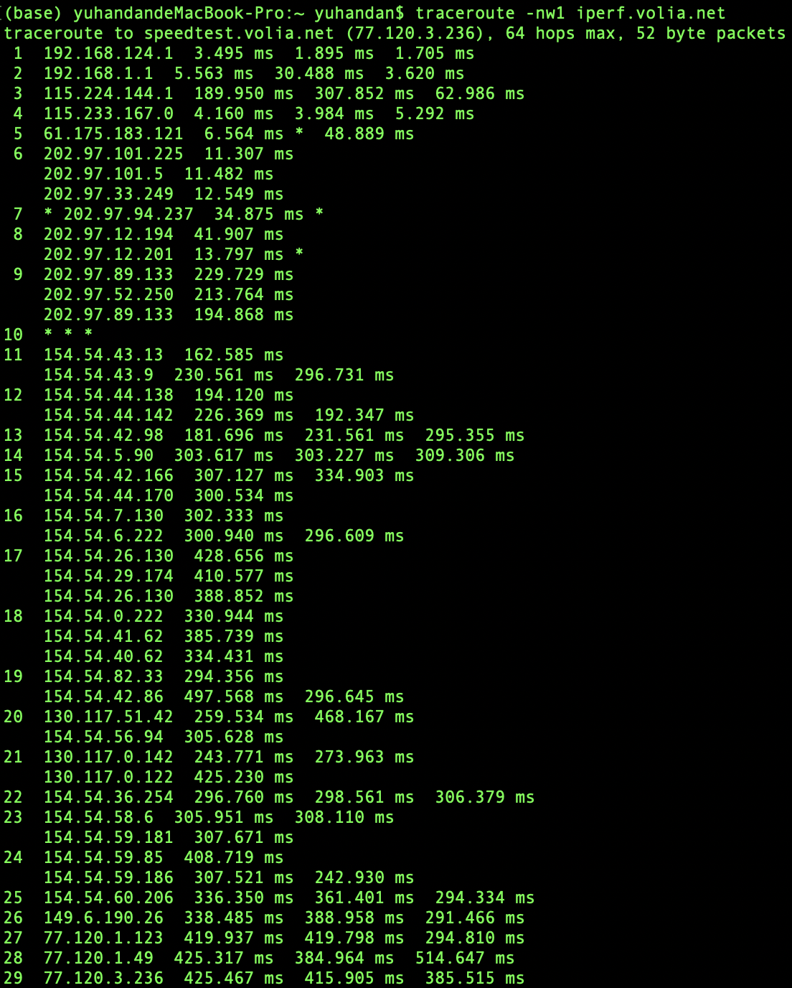

**Section 3**

**Ans 3.1** Looking at Fig <insert number> and the result achieved in section 3 of the appendix....

<Place your figure Here>

Some more info about your analysis...

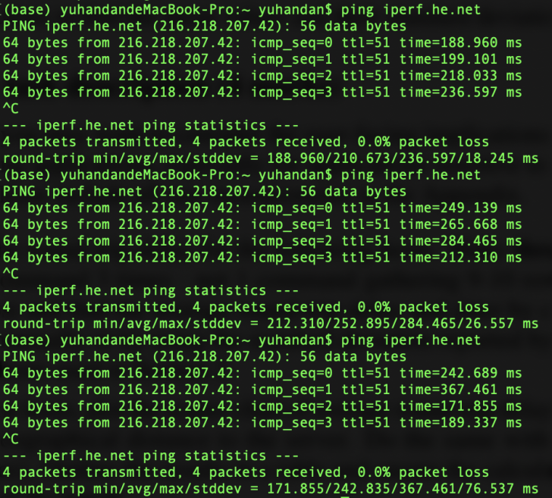

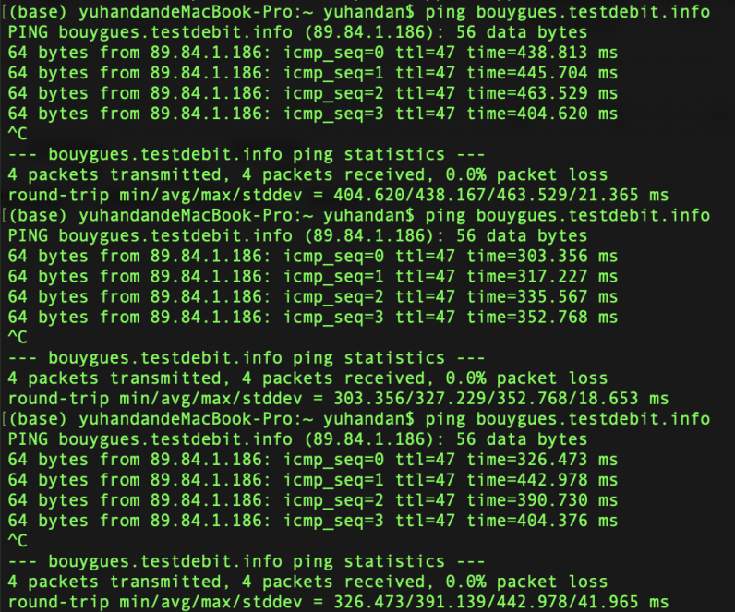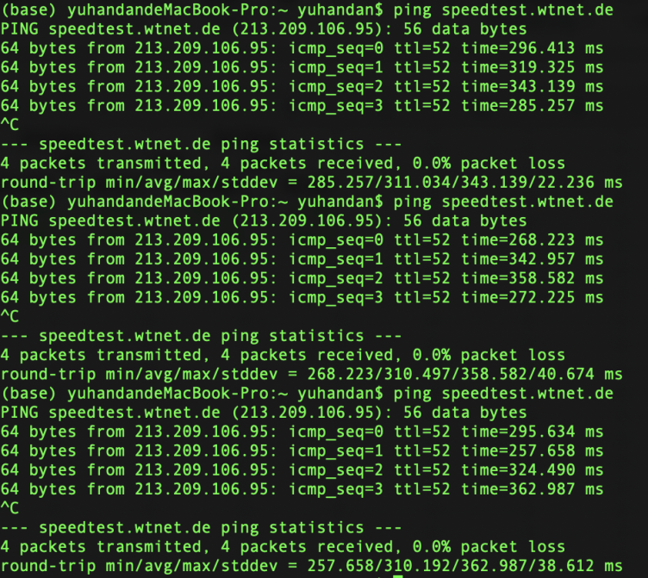

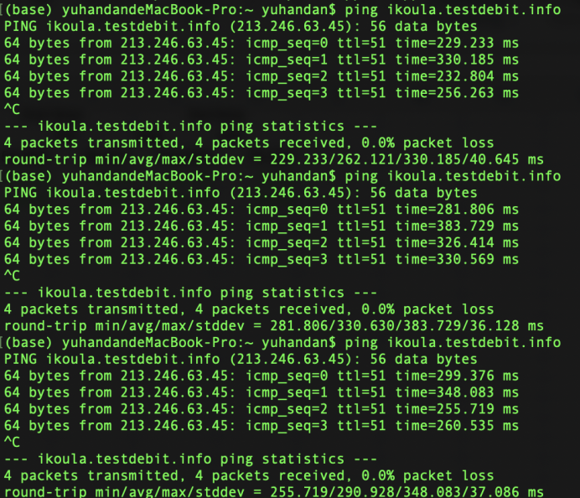

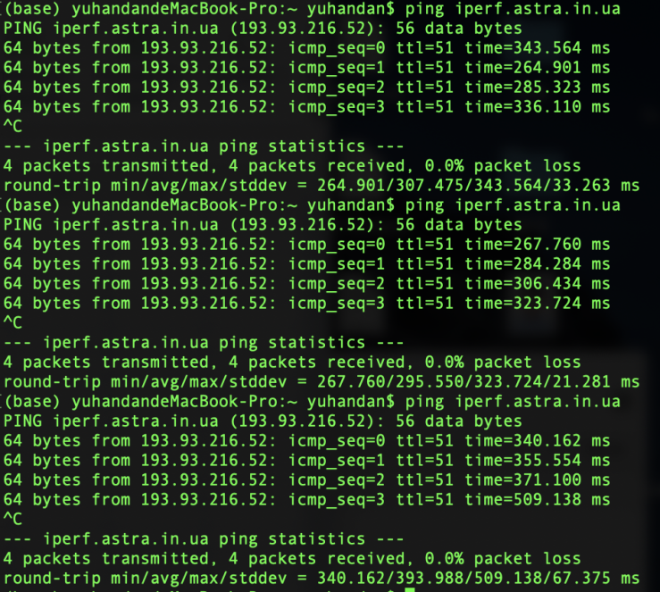

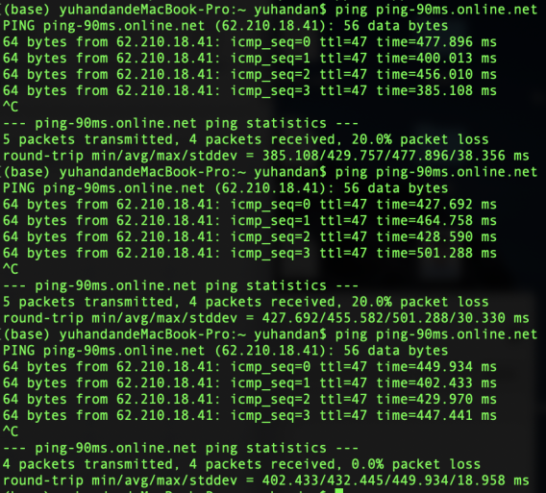

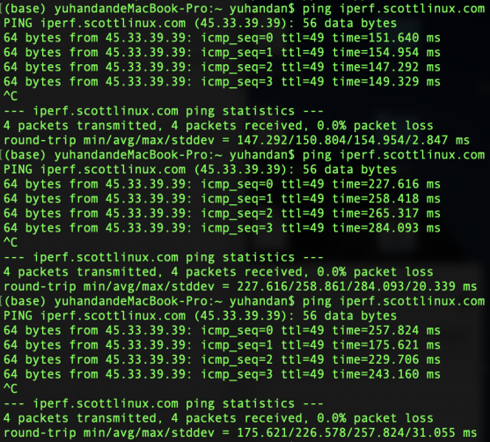

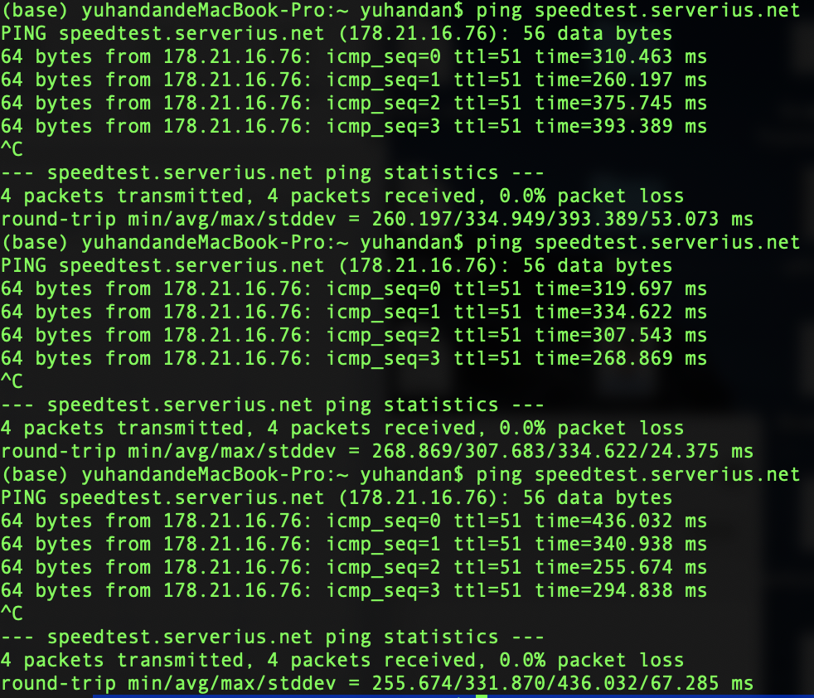

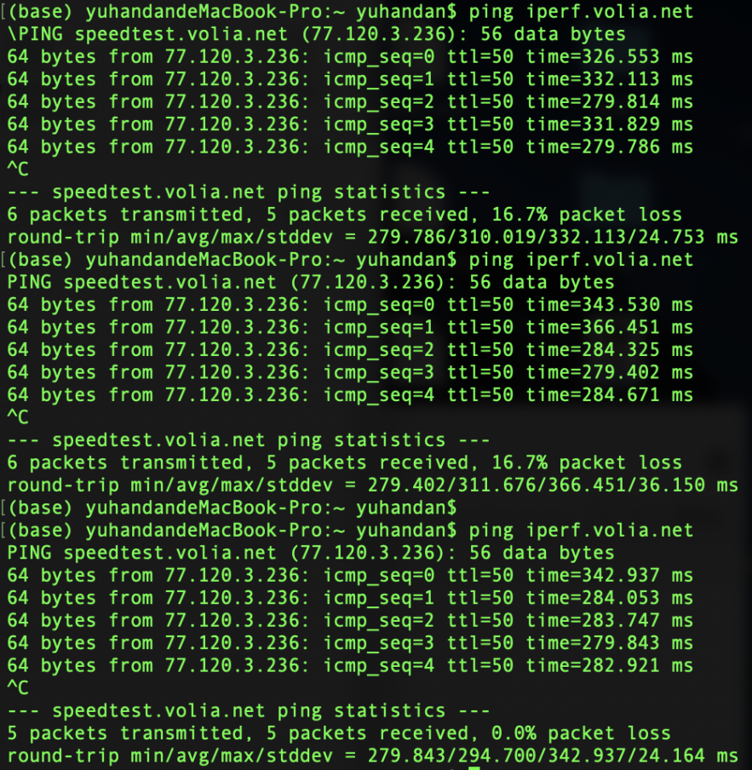

**Ans 3.2** Looking at Fig <insert number> and the result achieved in section 3 of the appendix....

<Place your figure Here>

Some more info about your analysis...

**Section 4**

**Ans 4.1** Looking at Fig <insert number> and the result achieved in section 4 of the appendix....

<Place your figure Here>

Some more info about your analysis...

**Ans 4.2** Looking at Fig <insert number> and the result achieved in section 4 of the appendix....

<Place your figure Here>

Some more info about your analysis...

**Ans 4.3** Looking at Fig <insert number> and the result achieved in section 4 of the appendix....

<Place your figure Here>

Some more info about your analysis...

**Ans 4.4** Looking at Fig <insert number> and the result achieved in section 4 of the appendix....

<Place your figure Here>

Some more info about your analysis...

**Ans 4.5** Looking at Fig <insert number> and the result achieved in section 4 of the appendix....

<Place your figure Here>

Some more info about your analysis...

**References**

Use a consistent referencing scheme: <https://library.unimelb.edu.au/recite>

**Appendix**

Section 2

<Insert Images of results – screenshots of terminal/cmd>

<Insert Calculations>

Section 3

<Insert Images of results – screenshots of terminal/cmd>

<Insert Calculations>

Section 4

<Insert Images of results – screenshots of terminal/cmd>

<Insert Calculations>